7.3.2 Editors - 3D View - Sidebar - Tool Tab
Tool Tab 1
Tool Tab and Top Bar 1
Workspace Panel 1
Top bar tools arrangement 2

Tool Tab
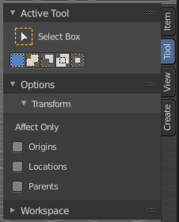
In the tool tab you will find the tool related settings for the tools in the tool shelf. In Weightpaint mode you have for example all brush related panels.

The tool specific entries are explained in the tool shelf chapter. The brushes panels are explained in the tool tab chapters.

Tool Tab and Top Bar

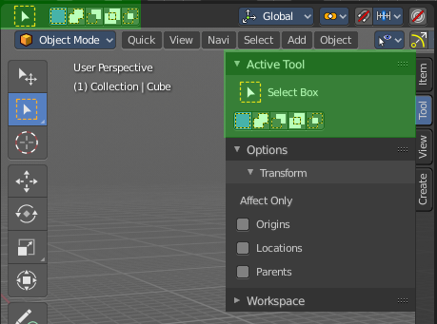
The content in the Tool Tab is besides one panel the same than in the Topbar. The panel called Workspace just exists in the sidebar.
The content of the Options panel changes, dependant of the object type and the mode. And will be described in other tool tab chapters.

Workspace Panel
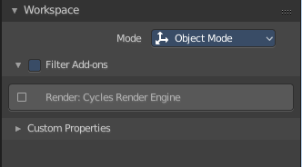
Workspaces can be configured to start in specific modes, and with a specific sets of active addons. This is the place where you configure this settings.
You have to save the startup file to make these changes permanent.

Mode
The mode in which the 3D view should start when you switch to this workspace layout.

Filter Addons
Here you can filter, means activate or deactivate specific addons.

Custom Properties
Custom properties allows you to store your own metadata. This metadata cna then be used for rigging and Python scripts.
The following data supports custom properties:
- All data-blocks types.
- Bones and Pose-Bones.
- Sequence strips.

Top bar tools arrangement

The tools in the top bar are arranged in a special way. Left you have the tools area. At the right you will find further options in case there are any. This is a general UI design paradigm. Left tools and menus, right settings.

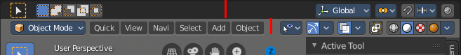

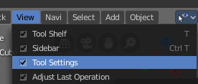
In the 3d view the tool settings area doesn't just contain the content of the Tool Tab. But also some general workspace settings. You can hide the Tool settings. And then those general settings appears in the header.

